Mary Cassatt (1824 - 1926)

Mary Cassatt was an American painter and printmaker from the latter half of the nineteenth century who lived the majority of her adult life in France. She is the only American to have exhibited with the Impressionists and was instrumental in promoting Impressionist works to American collectors, particularly the Havemeyer family. Like the other Impressionists, Cassatt specialised in scenes of contemporary daily life. Her primary subjects were her family and the entertainments that were appropriate for a lady of good breeding such as the theatre and the opera. Cassatt worked in multiple media including oil, pastel and was particularly innovative in printmaking. Current scholars often view Cassatt as a forerunner to feminism due to her formally daring work, which combined Japanese and European influences, and successful career at a time when women were almost completely excluded from professional pursuits. Cassatt is most celebrated for her mother and child scenes and, while earlier critics praised Cassatt for her female insight into the maternal subject, current scholarship encourages a more nuanced interpretation that does not use gender as an explanation for subject matter or style. Cassatt remained independent throughout her life, never marrying or having children.

Cassatt came from a wealthy family and her choice to pursue an artistic career was extremely unusual. She began studying art at the Pennsylvania Academy of the Fine Arts, Philadelphia in 1860. In 1866 Cassatt travelled extensively across Europe copying the works of old masters and studying with a variety of academically trained painters. She eventually settled in Paris and exhibited work in the Paris Salon, the official art exhibition of the Académie des Beaux-Arts in 1868, 1870 and 1872–6. During the late 1870s, Cassatt’s style became more innovative and she began to scorn the conventional art of the Academy. She was invited by Edgar Degas to exhibit with the Impressionists in their fourth annual exhibition of 1879 and this began their long friendship. She was fully accepted as part of the movement and took part in the Impressionist exhibitions of 1880, 1881 and 1886.

During the 1880s and 1890s Cassatt worked in etching, aquatint and drypoint both independently and in collaboration with Degas and Camille Pissarro. Her greatest achievement in printmaking was her suite of coloured etchings that depict women in everyday settings such as bathing, writing a letter or riding a tram (1891). These prints incorporate a flattened perspective and emphasis on decorative pattern that was inspired by Japanese Ukiyo-e prints that were in vogue among avant-garde artists at the turn-of-the-century.

In 1891, Cassatt had her first solo exhibition at the Galerie Durand-Ruel, Paris and she was invited to create a mural, The Modern Woman, for the Woman’s Building at the World’s Columbian Exposition (Chicago, 1893). This mural was not received well by the critics but her works in other media (such as oil and pastel) were highly successful in both France and America. With the proceeds from her work she purchased a château in France. Cassatt painted until 1915 when cataracts prevented her from working. However, she continued to show an active interest in art until her death in 1926.

References and Further Reading

Breeskin, A. D. (1979). Mary Cassatt: A catalogue raisonné of the graphic work, Washington: Smithsonian Institution Press.

Cassatt, M., & Mathews, N. M. (1984). Cassatt and her circle: Selected letters, New York: Abbeville Press.

Johnson, R. S., Johnson, U. M., & Varkalis, S. (2011). Mary Cassatt: Early graphic works 1878-1891, Chicago: R.S. Johnson Fine Art.

Pollock, G. (1998). Mary Cassatt: Painter of modern women. London: Thames & Hudson.

Segard, A. (1913). Un peintre des enfants et des mères, Mary Cassatt. Paris: P. Ollendorff.

See image below from Artstor [http://library.artstor.org/library/#1] with their identifying information

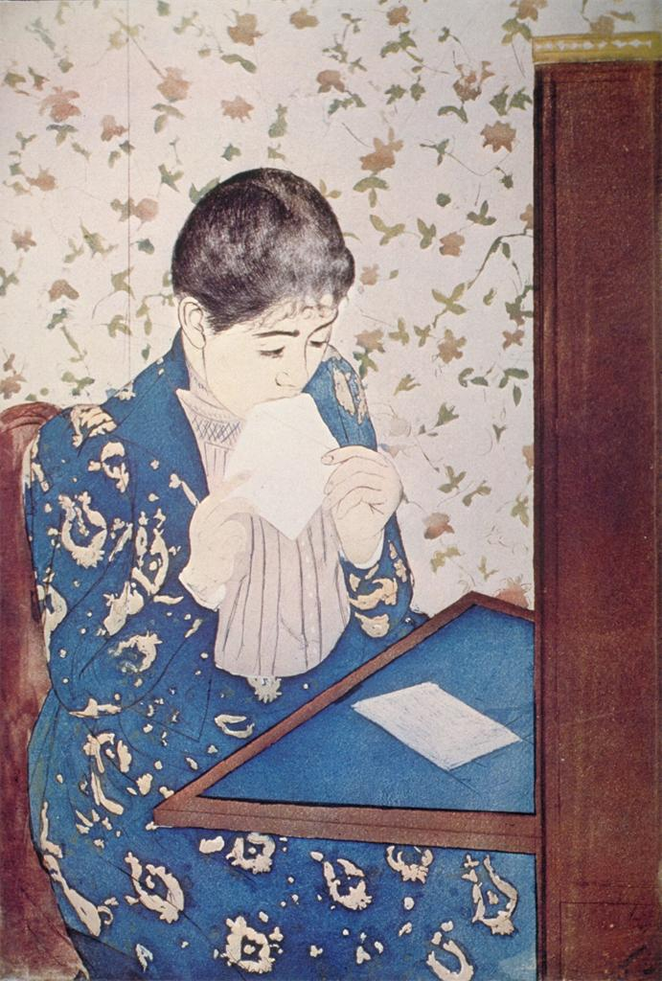

Cassatt, Mary, U.S.
Title | The Letter
Date | 1891
Material | drypoint, etching and aquatint
Measurements | 432x302mm.
Related Item | Adams AAT: 23.25
ARTstor Collection | Art History Survey Collection
Source | Catalogued by: Digital Library Federation Academic Image Cooperative
Download Size | 10,241,024

